The Curiosity Paradox
Jonathan Paradox Lee
Grant Robert Miller
2832 SE 21st Ave.
Portland, OR 97202
www.TheCuriosityParadox.com
Work@TheCuriosityParadox.com
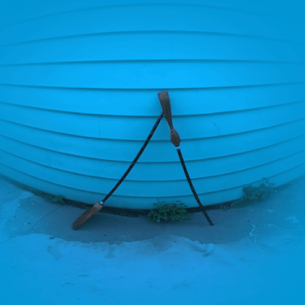
[A warped blue circle. Two brooms stand to form a triangle.]

What We Do.
Disability Equity and Access Consultation, Facilitation, and Art Making.

How We Do It.
At The Curiosity Paradox, we consider the seemingly benign aspects of gathering people together and reframe them as a fertile ground of solidarity, resistance, learning, and creativity.

Some Of Our Clients.
The City of Portland | Portland Institute for Contemporary Art (PICA) | Disability Art and Culture Project | On the Boards: “Salvage Exchange” | Playground of Empathy: Get in the Shoe | Portland Art Museum | PHAME | Calling Up Justice | Women’s Theater Festival

What Participants In Our Programs Say.
“I'm not one to jump in and speak in a group of strangers but it felt natural in this co-created space.”
“There was really love in this room in asking and answering questions.”
“[This program] really challenged my notion of access. I really had to rethink everything. Which, to me, was such an amazing endeavor.”

Some Of What We’ve Done.

Dis/Rep (June 2020 – Present)
Co-producers. Anti-ableist virtual learning space that models accessibility and teaches Disability art and justice-related topics. Funded by The City of Portland through 2025. Dis/Rep Info.

Crip Create (February 2020 – Present)
Co-creator. A disability justice centered co-working space, built in collaboration with Disability Art and Culture Project. Funded by Regional Arts and Culture Council. Crip Create Program.

Justice Producer’s Collaborative (July 2020 – Present)
Co-creator. The Justice Producer’s Collaborative gives signal boosting and mutual aid for marginalized equity workers and artists whose work centers justice. Self-organized. JPC on Instagram.

Threshold Practice (2018-Present)
Co-creators, Educators. Threshold Practice is a training that centers collective care and counter-ableism. Past facilitations include Portland Playhouse, PICA , Lewis & Clark College.

Unsettling Dramaturgy (2017 – present)
Collaborator, Curator. Colloquium of Crip and Indigenous dramaturgs from across Canada and the US who work in theatre, dance, and experimental performance. Funded by Canada Council for the Arts. Unsettling Dramaturgy Homepage.

Electra, Women’s Theater Festival (2021)
Access Dramaturgs, Ensemble Member. Adrienne Kennedy’s Electra, directed by Claudia Alick. Award winning, including outstanding Achievement in Accessibility. Funded by individual donors. Electra Info.

Press and Panels.
“Demanding Access: Women and Nonbinary Disabled People Making Theater On Their Own Terms.” Panel for WTFcon21 (2021) Panel Info.
“Practicing Disability Justice, Honoring Wholeness Onstage,” by Lydia XZ Brown in American Theater Magazine (2021) Article Text.

